Four Key Archetypes – Carl Jung worksheet
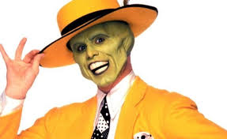
The Persona
The persona is how we present ourselves to the world. The word "persona" is derived from a Latin word that literally means "mask." It is not a literal mask, however. The persona represents all of the different social masks that we wear among various groups and situations. It acts to shield the ego from negative images. According to Jung, the persona may appear in dreams and take different forms.1﻿
Over the course of development, children learn that they must behave in certain ways in order to fit in with society's expectations and norms. The persona develops as a social mask to contain all of the primitive urges, impulses, and emotions that are not considered socially acceptable. The persona archetype allows people to adapt to the world around them and fit in with the society in which they live. However, becoming too closely identified with this archetype can lead people to lose sight of their true selves.
The Shadow
The shadow is an archetype that consists of the sex and life instincts. The shadow exists as part of the unconscious mind and is composed of repressed ideas, weaknesses, desires, instincts, and shortcomings. The shadow forms out of our attempts to adapt to cultural norms and expectations. It is this archetype that contains all of the things that are unacceptable not only to society, but also to one's own personal morals and values. It might include things such as envy, greed, prejudice, hate, and aggression. This archetype is often described as the darker side of the psyche, representing wildness, chaos, and the unknown. These latent dispositions are present in all of us, Jung believed, although people sometimes deny this element of their own psyche and instead project it on to others. Jung suggested that the shadow can appear in dreams or visions and may take a variety of forms. It might appear as a snake, a monster, a demon, a dragon, or some other dark, wild, or exotic figure.
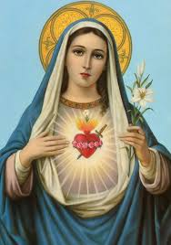
The Anima or Animus
The anima is a feminine image in the male psyche, and the animus is a male image in the female psyche. The anima/animus represents the "true self" rather than the image we present to others and serves as the primary source of communication with the collective unconscious. Jung believed that physiological changes as well as social influences contributed to the development of sex roles and gender identities. Jung suggested the influence of the animus and anima archetypes were also involved in this process. According to Jung, the animus represents the masculine aspect in women while the anima represented the feminine aspect in men.These archetypal images are based upon both what is found in the collective and personal unconscious. The collective unconscious may contain notions about how women should behave while personal experience with wives, girlfriends, sisters, and mothers contribute to more personal images of women. In many cultures, however, men and women are encouraged to adopt traditional and often rigid gender roles. Jung suggested that this discouragement of men exploring their feminine aspects and women exploring their masculine aspects served to undermine psychological development.1﻿﻿

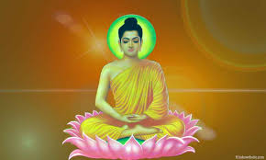
The Self
The self is an archetype that represents the unified unconsciousness and consciousness of an individual. The self archetype represents the unified psyche as a whole. Jung suggested that there were two different centres of personality. The ego makes up the centre of consciousness, but it is the self that lies at the centre of personality. Personality encompasses not only consciousness, but also the ego and the unconscious mind. For Jung, the ultimate aim was for an individual to achieve a sense of cohesive self, similar in many ways to Maslow's concept of self-actualization.
Archetype | Harry Potter | Marvel Universe/Disney
Hero
Villain
Maiden
Sidekick
Wiseman
Heroine
Nemesis

